**SIKSHA ‘O’ANUSANDHAN**

## DEEMED TO BE UNIVERSITY

**Admission Batch:2020 Session: 2020-2021**

Project Report

# Programming and Data Structures using C (CA3001)

***Submitted by***

Name: Biswajit Biswal

Registration No.: 2061020070

Branch: MCA

Semester: 1st Section: ‘B’



**Department of Computer Science & Engineering Faculty of Engineering & Technology (ITER)**

**Jagamohan Nagar, Jagamara, Bhubaneswar, Odisha – 751030**

|  |  |
| --- | --- |
| Ex.No.**17**  **16.03.2021** | **PROJECT REPORT - SUMMARY** |

|  |
| --- |
| **AIM:** |

Here, you can perform functions such as add books, return books, issue books, delete record of books issued, view record of books issued, search for books, and more. File handling has been extensively used in this project for almost all functions.

These are the functions used in this mini project:

* void mainmenu(void) – This function is used to display the main menu of this project. Scroll down to Output to view the main menu.
* void returnfunc(void) – Inside this function, the main menu function (mentioned above) is called when the user presses a key. With this, the user can return back to the main menu.
* void add books(void) – This function adds books in a file. For that, you need to mention the department to which you want to add the book. The record is saved in a file. And, it is similar for the following functions as well.
* void delete books(void)
* void edit books(void)
* void search books(void)
* void issue books(void)
* void view books(void)
* void issue record() – With this function, you can keep record of the student to whom the book has been issued.
* void close application(void) – This function is for closing the application.
* int get data() – This function asks for data input from the user.

**Library Management System**

**Book Information:-**

Step1-START

Step2-Read book-name, author,pages,price

Step3-Count++;

Step4-For(i=0;i<count++)

Display book-name, author,pages,price

Step5-STOP

**List of all books:-**

Step1-START

Step2-Read author name

Step3-for(i=0;i<count;i++)

If(Strcmp(arm,[i],author)==0)

Display book-name,author,pages,price

Step4-Read book name

Step5-For(i=0;i<count;i++)

If(Strcmp(bookNM,bookname)==0)

Display bookname, author, pages, and price

Step6-Stop

**Books in library:-**

Step1-START

Step2-Count

Step3-STOP

|  |
| --- |
| **RESULT:** |

This mini project in C Library Management System is a console application without graphic developed using the C programming language. In this, you can perform book-related operations like in a REAL library management system with computer.

|  |  |
| --- | --- |
| Ex.No.**18**  **16.03.2021** | **PROJECT REPORT - IMPLEMENTATION** |

**Book Information:-**

printf("Enter book name = ");

scanf("%s", l[i].bookName);

printf("Enter author name = ");

scanf("%s", l[i].author);

printf("Enter pages = ");

scanf("%d", &l[i].pages);

printf("Enter price = ");

scanf("%f", &l[i].price);

keepcount++;

**Output:-**

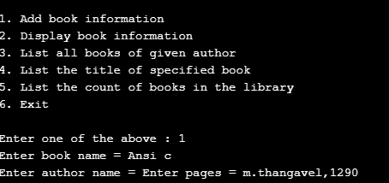

**List of all books:-**

printf("Enter author name : ");

scanf("%s", arNm);

for (i = 0; i < keepcount; i++)

{

if (strcmp(arNm, l[i].author) == 0)

printf("%s %s %d %f", l[i].bookName, l[i].author, l[i].pages, l[i].price);

}

break;

**Output:-**

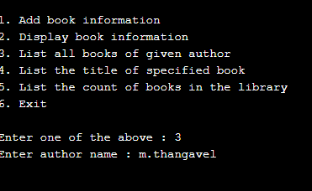

**Books in library:-**

printf("\n No of books in library : %d", keepcount);

break;

case 6:

exit(0);

}

}

return 0;

}

**Output:-**

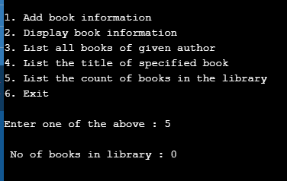

|  |
| --- |
| **RESULT:** |

This mini project in C Library Management System is a console application without graphic developed using the C programming language. In this, you can perform book-related operations like in a REAL library management system with computer.

#include <stdio.h>

#include <stdlib.h>

#include <string.h>

struct library

{

char bookName[30];

char author[30];

int pages;

float price;

};

int main()

{

struct library l[100];

char arNm[30], bookNm[30];

int i, j, keepcount;

i = j = keepcount = 0;

while (j != 6)

{

printf("\n\n1. Add book information\n2. Display book information\n");

printf("3. List all books of given author\n");

printf("4. List the title of specified book\n");

printf("5. List the count of books in the library\n");

printf("6. Exit");

printf("\n\nEnter one of the above : ");

scanf("%d", &j);

switch (j)

{

/* Add book */

case 1:

printf("Enter book name = ");

scanf("%s", l[i].bookName);

printf("Enter author name = ");

scanf("%s", l[i].author);

printf("Enter pages = ");

scanf("%d", &l[i].pages);

printf("Enter price = ");

scanf("%f", &l[i].price);

keepcount++;

break;

case 2:

printf("you have entered the following information\n");

for (i = 0; i < keepcount; i++)

{

printf("book name = %s", l[i].bookName);

printf("\t author name = %s", l[i].author);

printf("\t pages = %d", l[i].pages);

printf("\t price = %f", l[i].price);

}

break;

case 3:

printf("Enter author name : ");

scanf("%s", arNm);

for (i = 0; i < keepcount; i++)

{

if (strcmp(arNm, l[i].author) == 0)

printf("%s %s %d %f", l[i].bookName, l[i].author, l[i].pages, l[i].price);

}

break;

case 4:

printf("Enter book name : ");

scanf("%s", bookNm);

for (i = 0; i < keepcount; i++)

{

if (strcmp(bookNm, l[i].bookName) == 0)

printf("%s \t %s \t %d \t %f", l[i].bookName, l[i].author, l[i].pages, l[i].price);

}

break;

case 5:

printf("\n No of books in library : %d", keepcount);

break;

case 6:

exit(0);

}

}

return 0;

}

**Output:-**

